You must keep these items if you have a lab
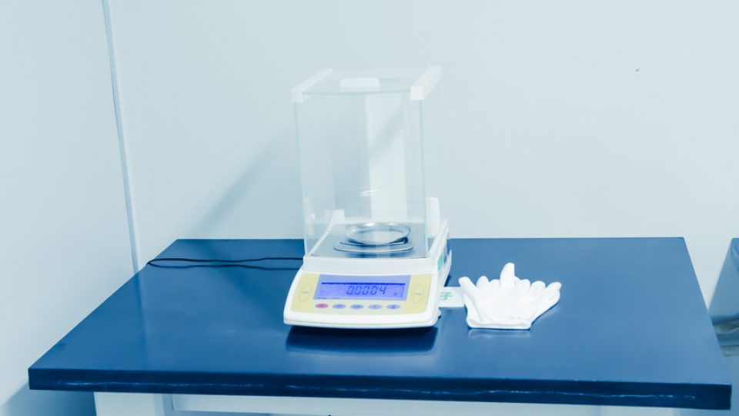
Laboratories are quite an important place as it is the place where then scientists perform their research and find out new facts and information that helps humans to grow and live a better life.
In today's advanced world, laboratories are of utmost importance, and if you have a lab or are planning to start a lab, then you must know the basics for it. There are some items that must be in your lab, as they are the necessary items.
You can contact any laboratory furniture manufacturer to get the best custom made furniture for your lab, but along with it, you must have some essential thing in your laboratory.
Some essential must-have things in your laboratory
Safety items
- A laboratory is full of different harmful toxins and fumes. The safety equipment are the first need of every lab.
- You must buy some essential safety equipment for your lab, such as goggles, lab coats, eyeglasses, gloves, etc.
- A single mistake can cause severe burns, loss of eyesight, and many other serious problems.
- You must wear these basic equipment while working in the lab, and you must havea fire extinguisher in your lab to handle any accidental fire.
Get More Information laboratory furniture manufacturer
Sinks
- Water is the most common element used in almost all experiments.
- You must have a good quality sink installed in the lab for proper water drainage.
- If your lab works on a larger scale, then you might have to install multiple sinks otherwise single sink in enough.
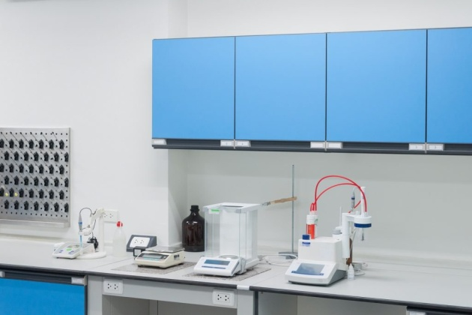
Hot plates
- You will need different temperatures to conduct various experiments, so you must have something to produce heat.
- Hot plates are considered to be the best to produce heat in the lab.
- You must ensure that the hot plates are durable so that they can withstand high temperatures without getting broken.

